Git practice

1.
Created a folder named practice_project and added a file named notes.txt in it.
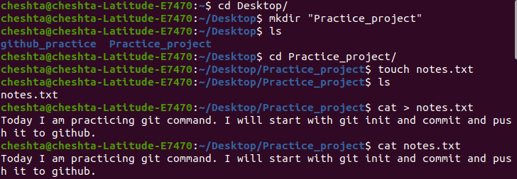
Used “ git status” command to check status.
Initialised git in the folder and used “git add” and “git commit -m” to add and commit the file.
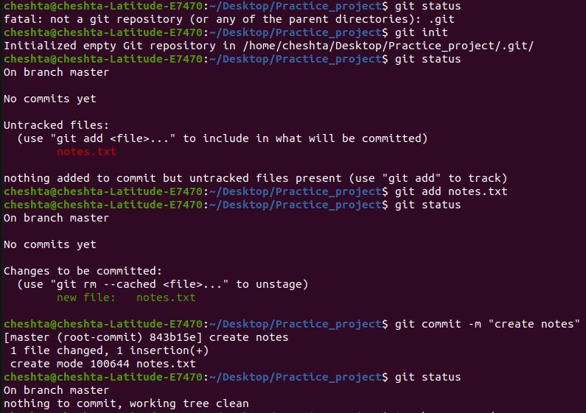

Created README.md and also add and commit it.
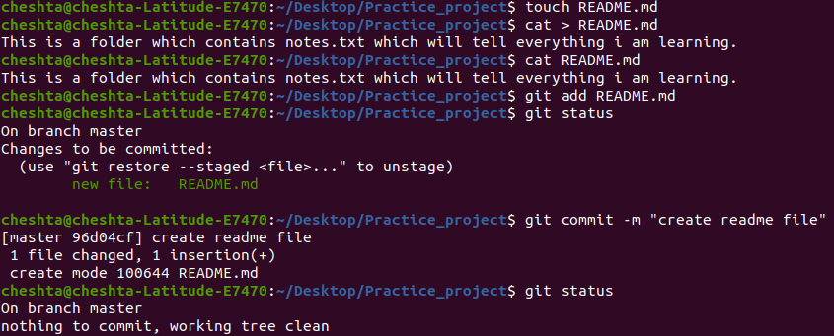
Changed name of branch from master to main and pushed repo to github.
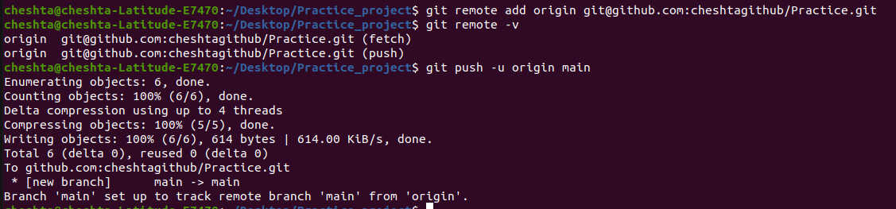
The pushed repo on github is:
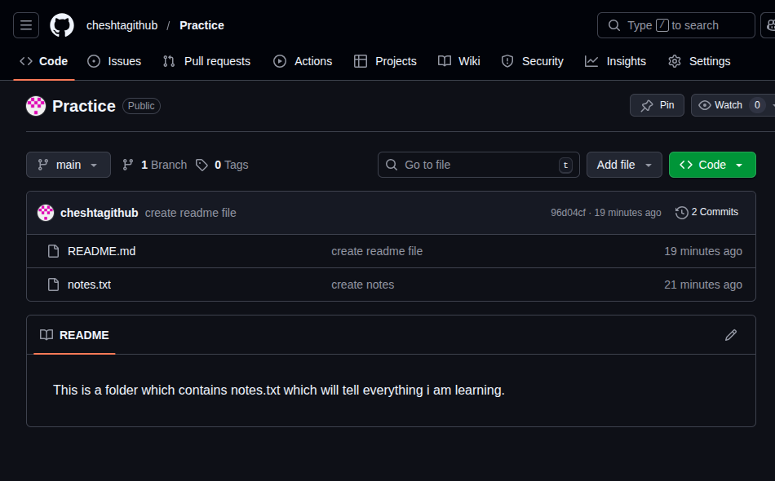

Now adding a new file tasks.txt
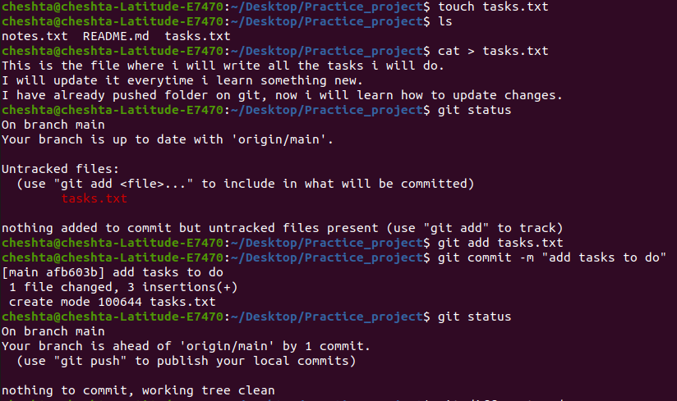
pushing changes on github
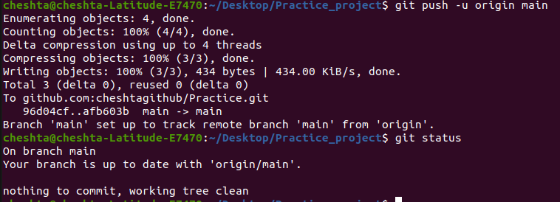
.
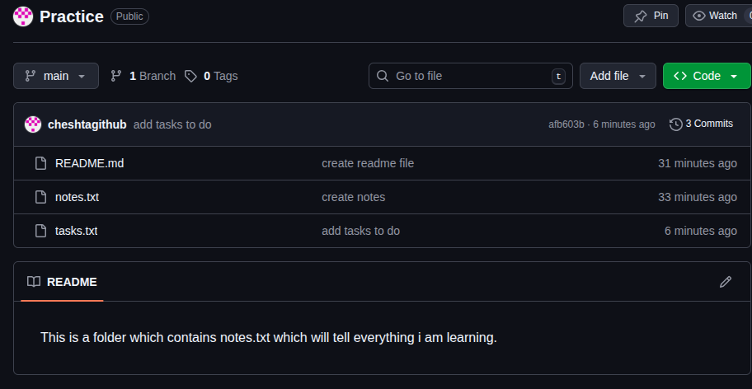
.

Making changes in a single file README.md
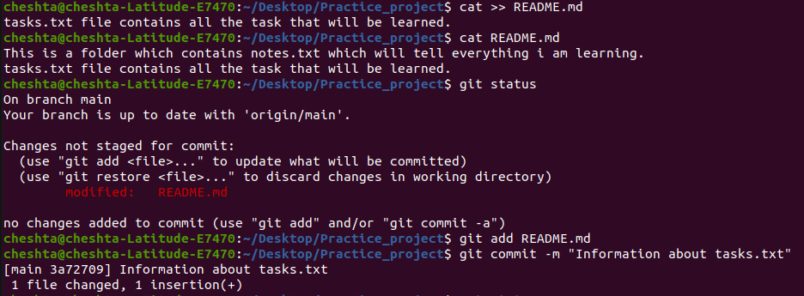
.
Pushing the commit to github:
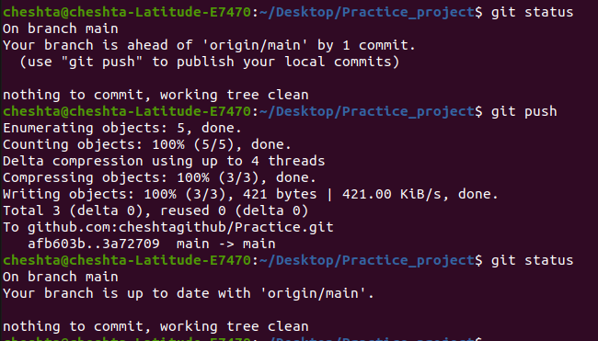
.
Updated README.md on github:
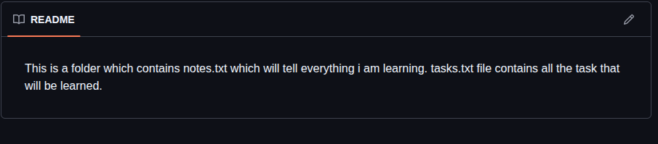
.

Used “git log” to get all the information aout the commit made.
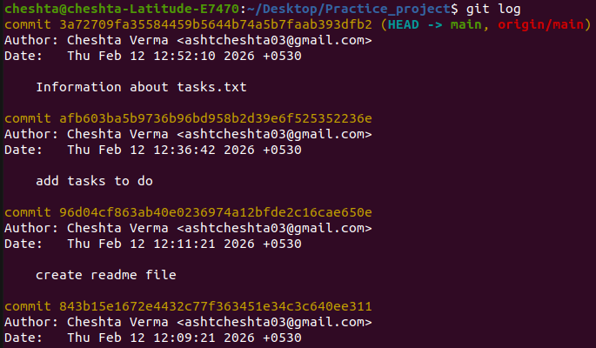
.
Add a file delete.txt:
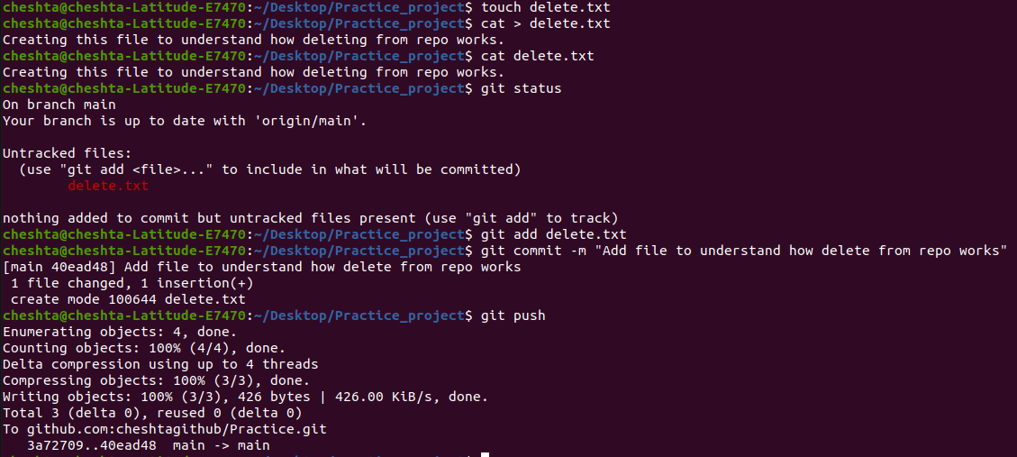
.
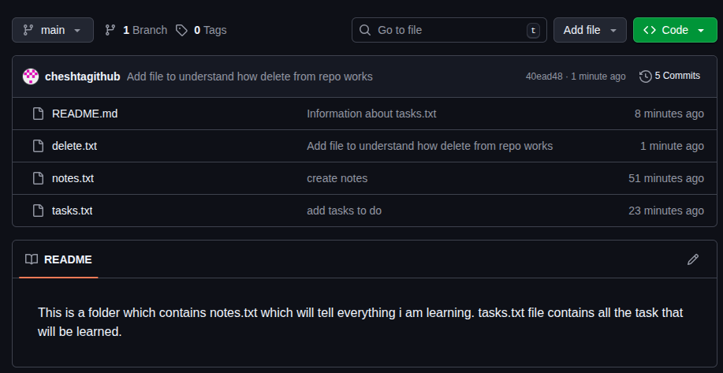
.
Deleting delete.txt:
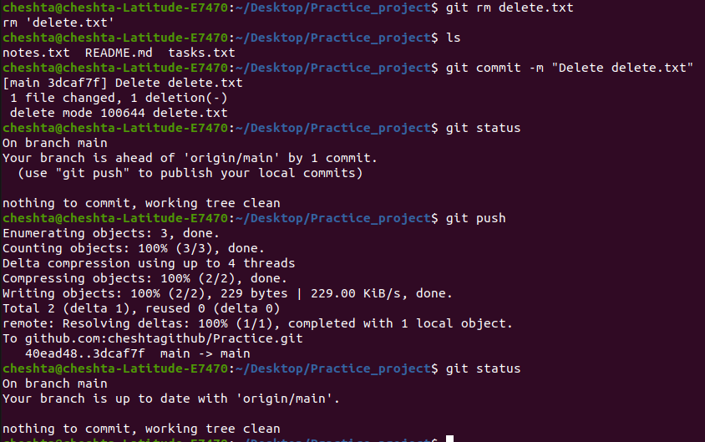
.
After deleting delete.txt github:
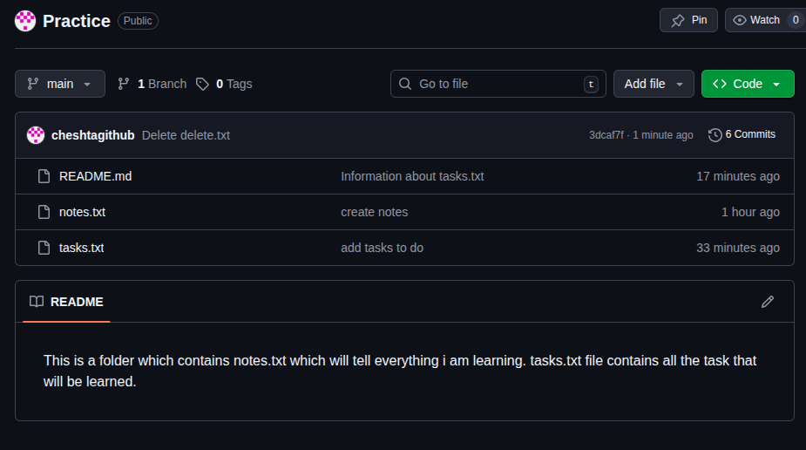
.

Making changes in more than one file and also using “git diff” to check the difference between commits.
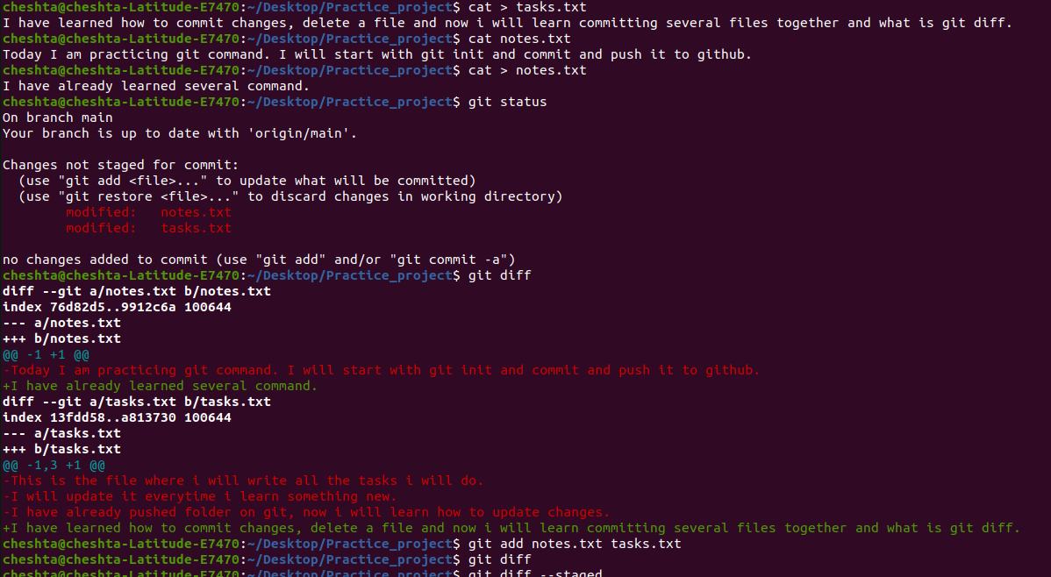
.
Pushing the changes to github and also using “git log --oneline” to check the different commits made.
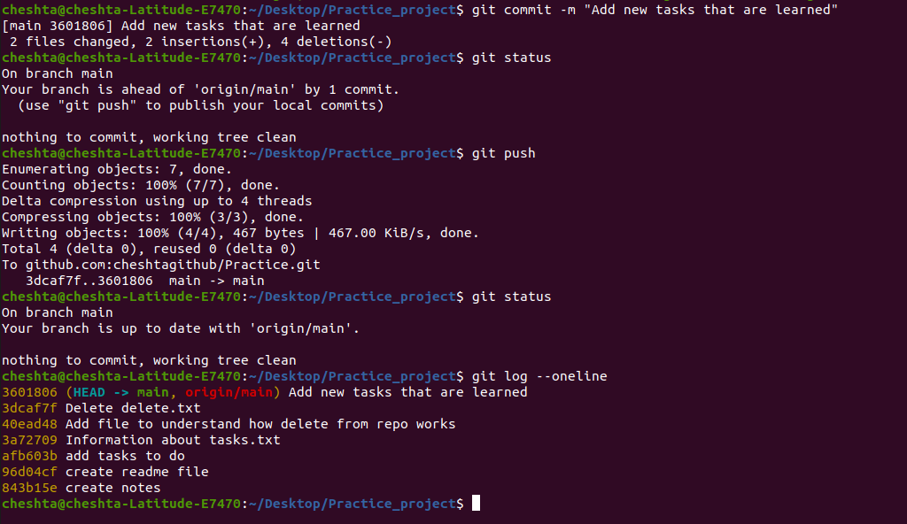
.

Created and pushed the new branch named new_branch to github:
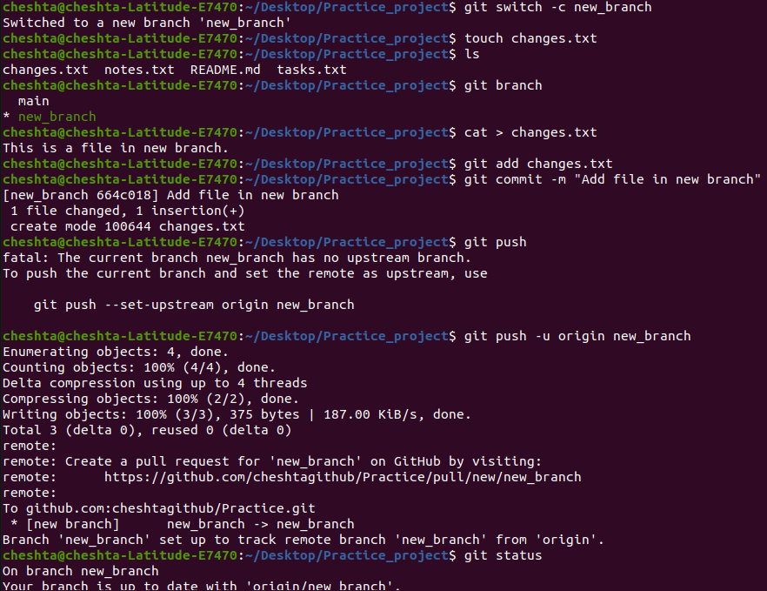
.
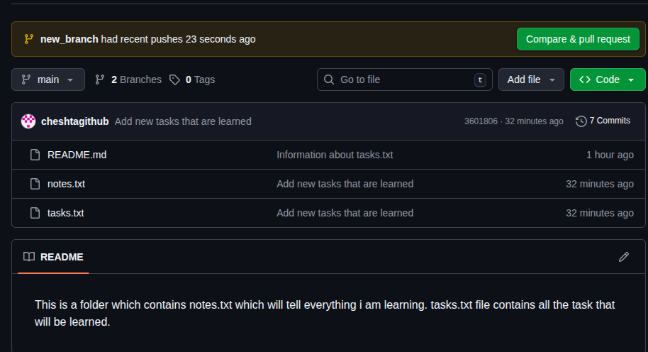

Merged new_branch with main branch
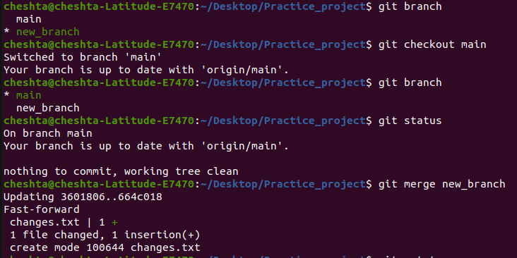
.
pushed the changes to github:
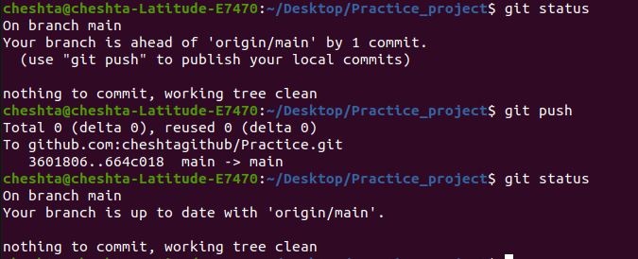
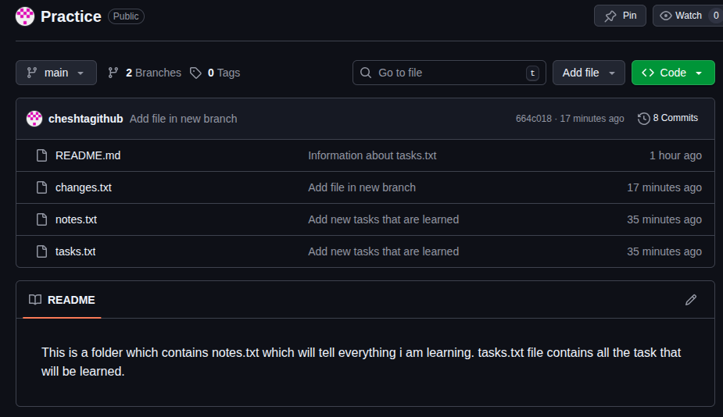
.

making changes in changes.txt in both main and new_branch :
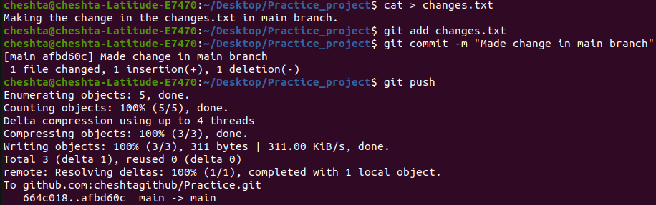
.
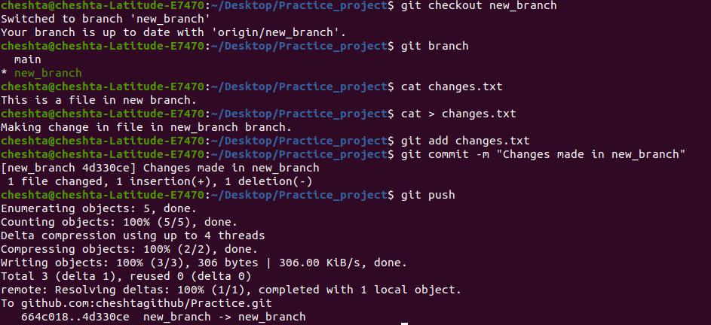
.
Github before merging
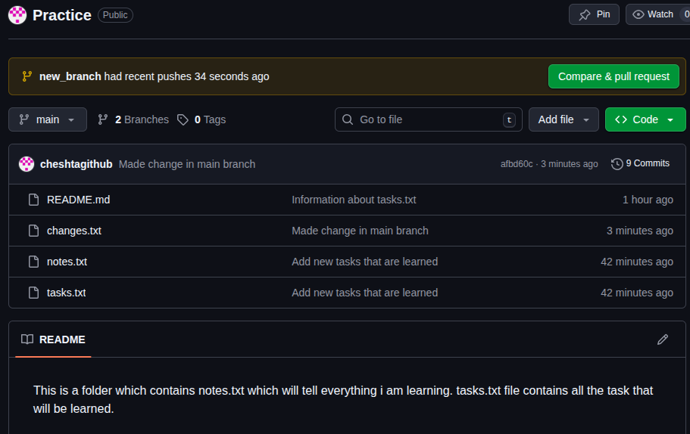
.

Merging and resolving conflict:
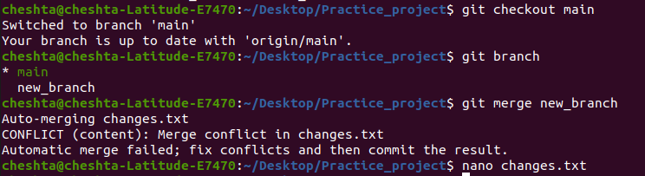
.Before resolving the conflict
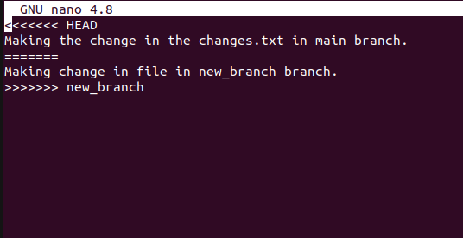
After resolving the conflict:
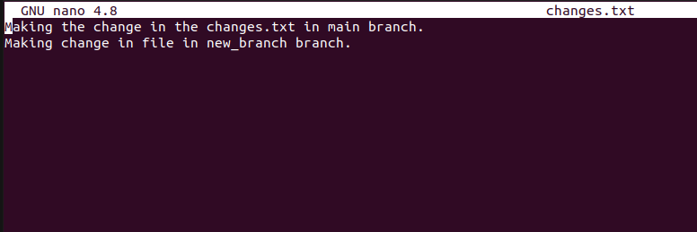
.commit the change in main branch:
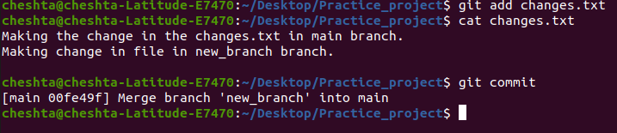
.
push it to github:
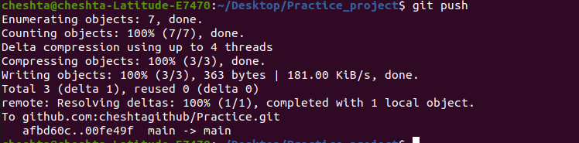
.
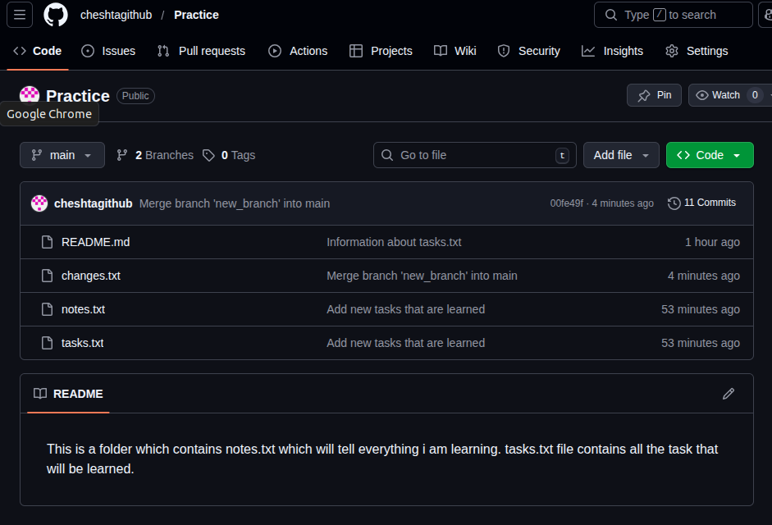
.
log of all the commits in oneline:
